**NAME: Edith Njoki Wangui**

**EMAIL ADDRESS:** [**edith.wangui@womentechsters.org**](mailto:edith.wangui@womentechsters.org)

**Practical Activity 5**

1. Adding headquarters and sales locations

Added Tech4dev HQ as my main headquarter

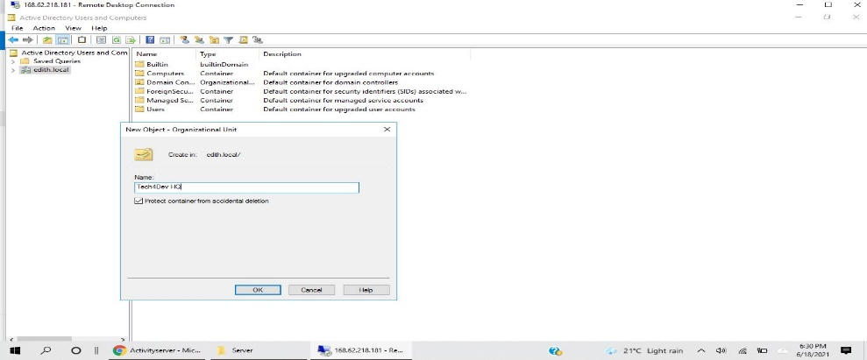

Tech4Dev HQ

1. Added groups in Tech4dev HQ and their dummy users

Account department

* Account department

1. Sally Oketch

Dummy user Sally

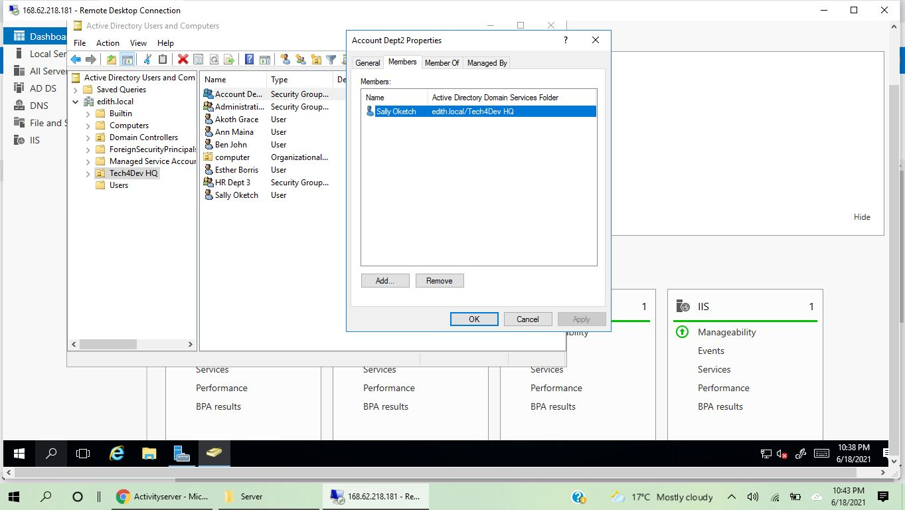

* Administration department

Administration Department

Dummy users Ann Maina

And Ben John

1. Ben John
2. Ann Maina

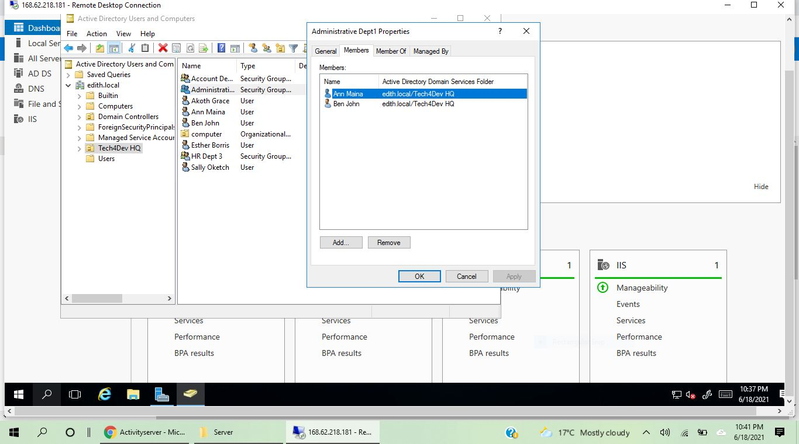

Hr department

Dummy users Akoth Grace and Esther Borris

* HR Department

1. Esther Borris
2. Akoth Grace

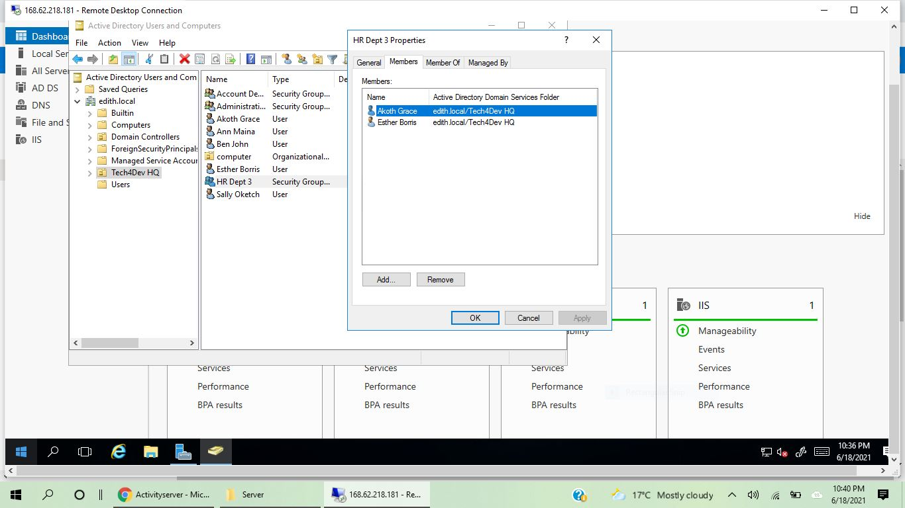

1. User is promoted from one department to the other

Ann Maina is promoted from Administrative department to Account department

Added Ann on Account Dept2 by clicking on account dept2 properties ----add----Ann Maina.

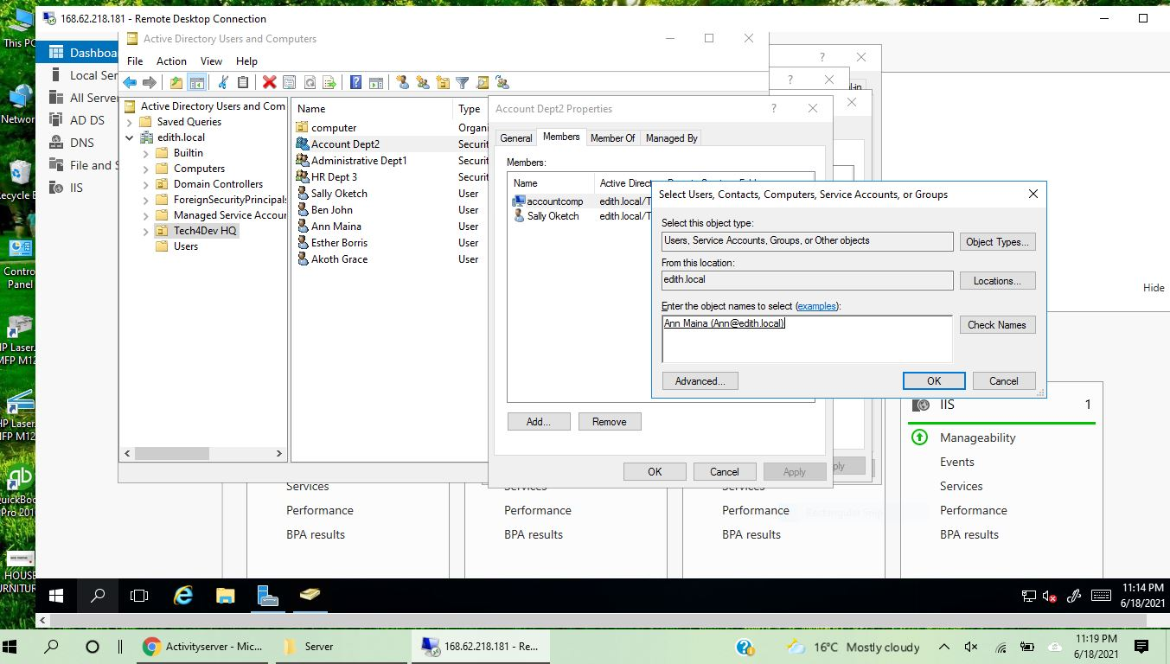

Click ok

3rd step

2nd step

1st step

1. Confirmed Ann Maina is now in the account department

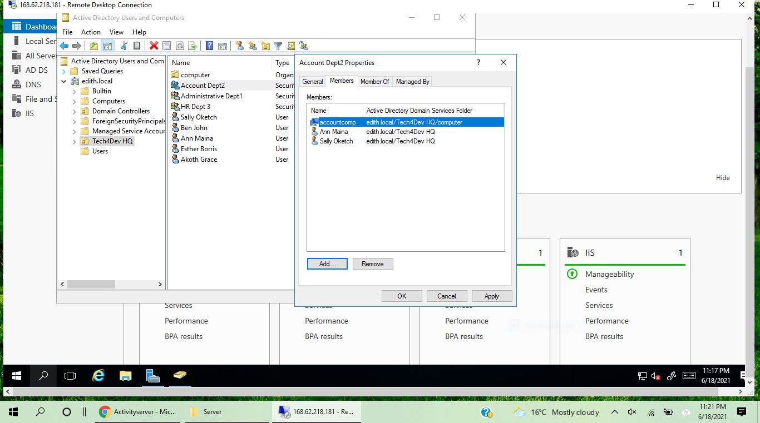

1. Removing Ann Maina from Administrative Department where she was before promotion

1st step

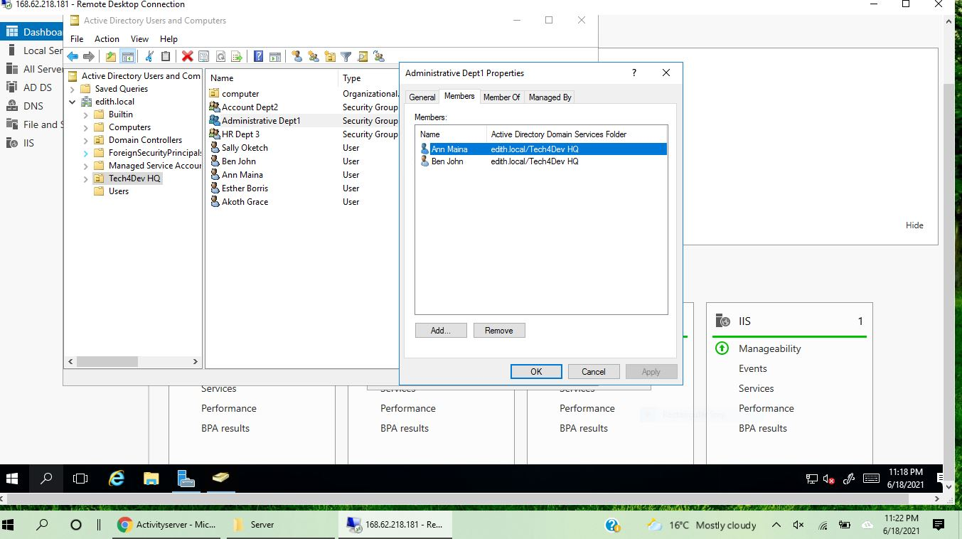

4th step

3rd step remove Ann Maina

2nd step

1. Confirming that Ann Maina is no longer in administrative department

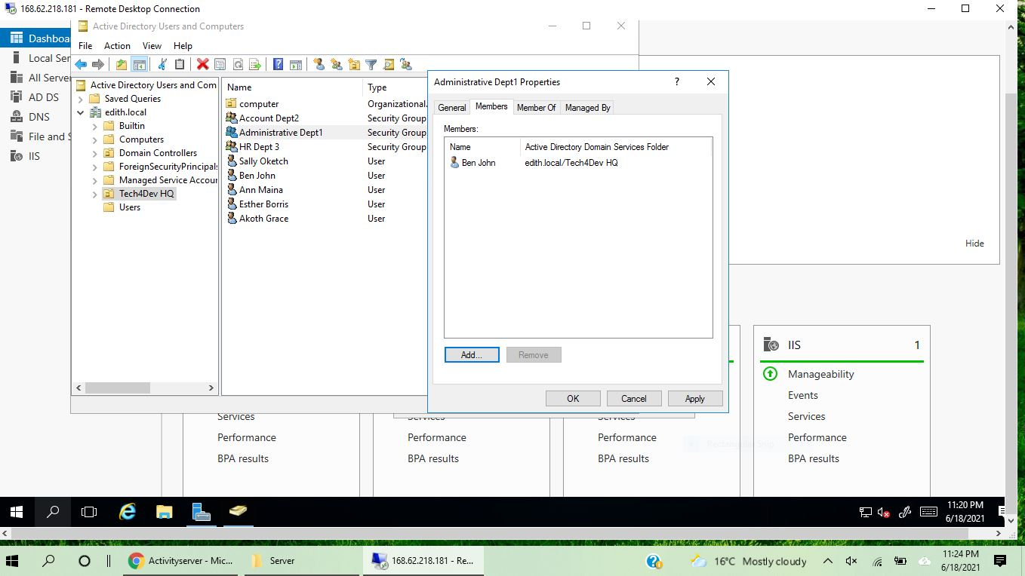

Ann is no longer in Administrative department

1. The primary group of Ann Maina is now the account department

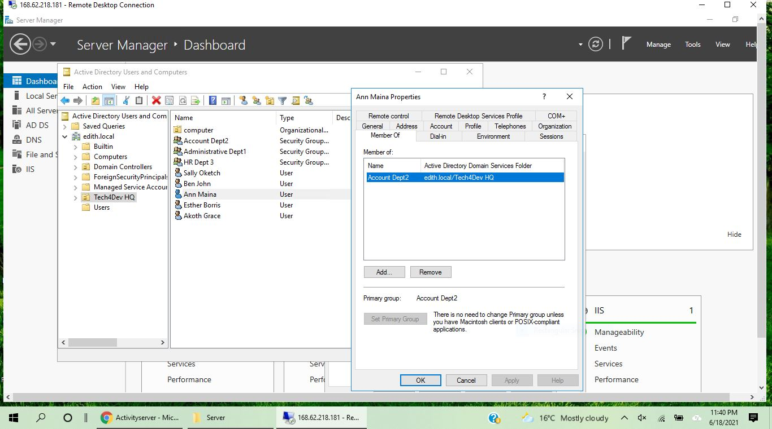

1. Disabling the user account for one month

Esther Borris from the HR department

2nd step

1st step

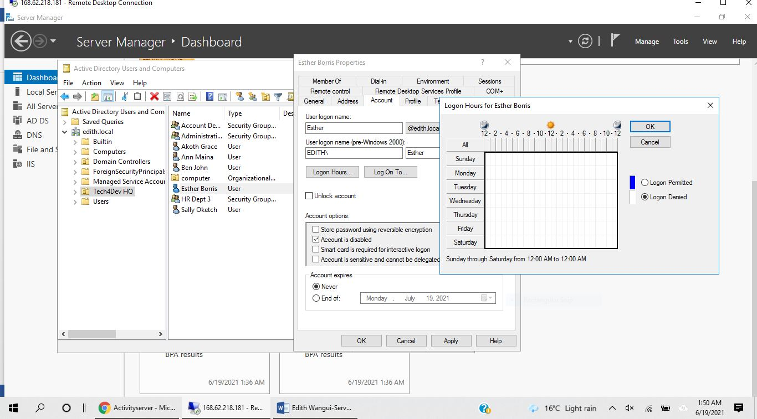

Enable the changes by clicking ok

Deny logon

Check to disable account

1. Adding a computer policy to ensure all computers are locked or disabled after 3 minutes of inactivity user has to log on back once again.

Created a group policy for the computer organizational unit on the Tech4Dev HQ

Under group policy management

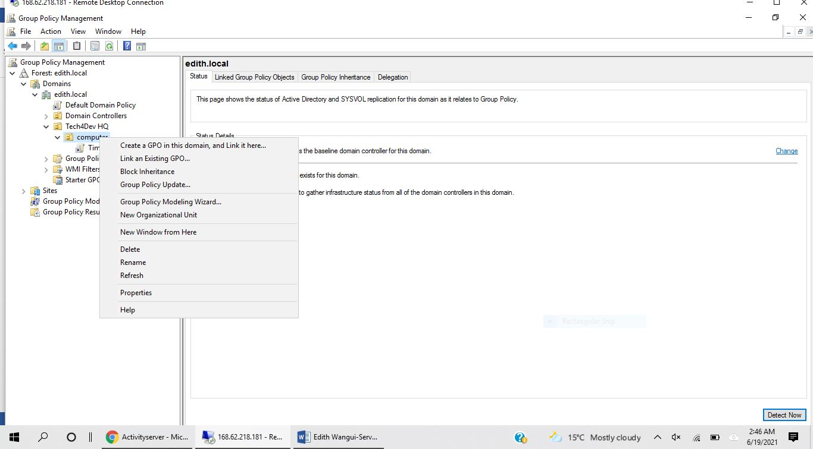

Named it Timeout 2

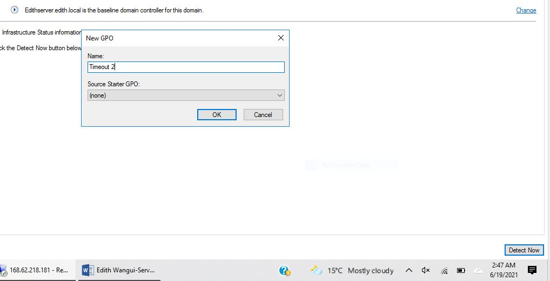

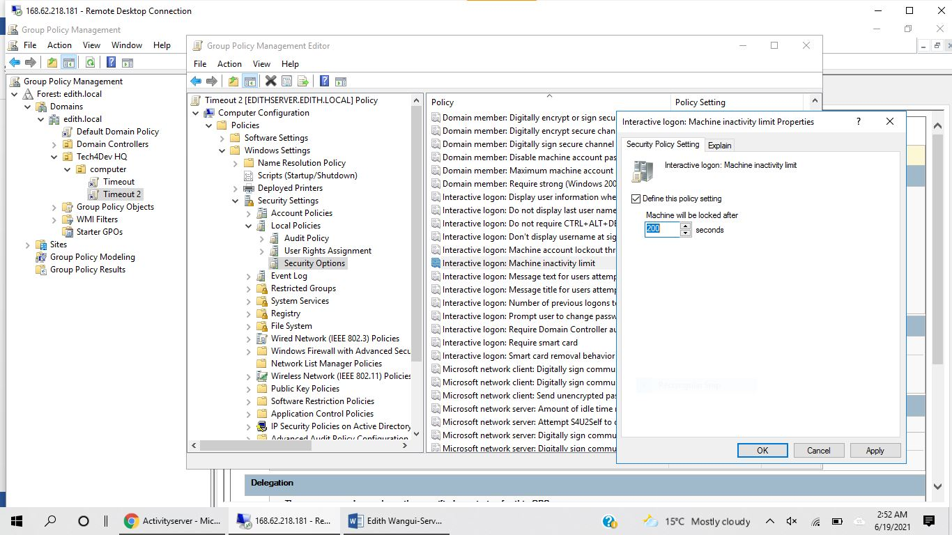

Last step to enable

Enabled 5 minutes

Interactive logon

Machine inactivity limit

Step 3 security options

Step 2

1st step

Confirmed after 5 minutes of machine inactivity is enabled

5 minutes

